NETFLIX_TITLES

The dataset has the data of the OTT platform called Netflix which contains 5 excel sheets related to each other. The distribution of data among the sheets has been described below using ER diagram.

1. Country Vs Count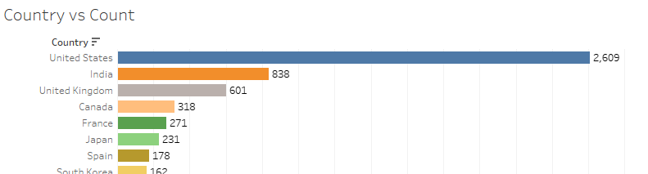

The above sheet represents the sum of movies and Tv shows produced by each country (aggregated by the country level).

2. Movies and TV shows

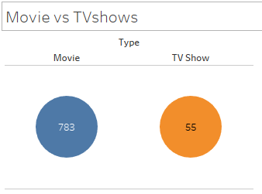

The above sheet contains the number of movies and Tv shows belongs to the different country (aggregated by the type).

3. Certified Vs Count

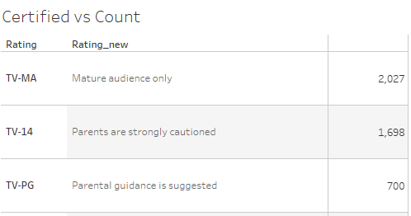

The above sheet contains the tabular data of sum of movie and Tv shows separated based on the Rating (Certification).

4. Certified Percent of total

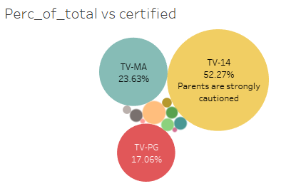

The above sheet specifies the percentage of movie that are belonged to the country based on the rating.

5. year of date added Vs Num of movies

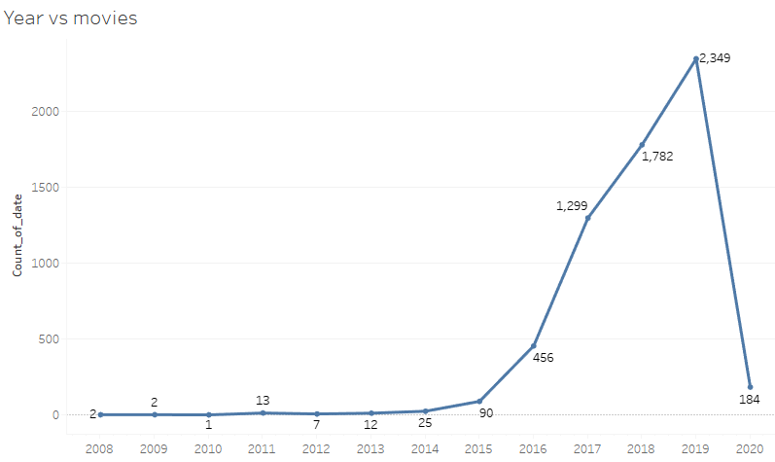

The above sheet contains the line graph showing the number of movies added to the Netflix on the year basis (aggregated by the year).

5.